


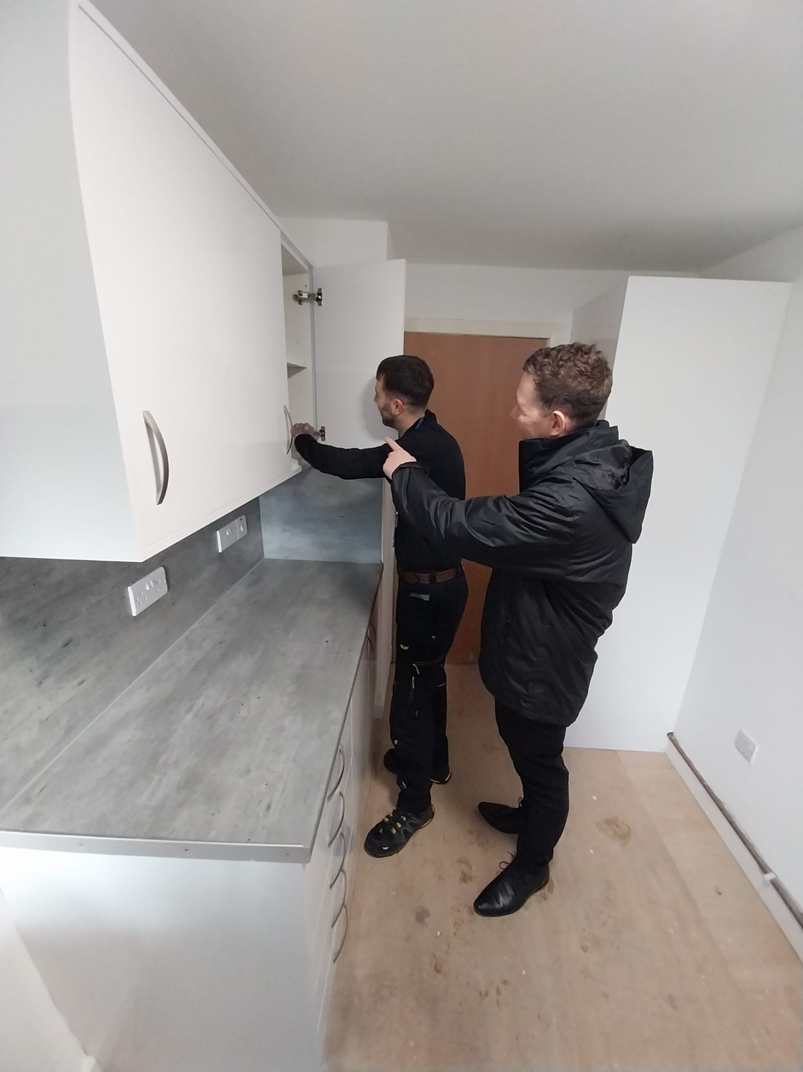



Contents

- Welcome
- About Easthall Park Housing Association
- Our Vision, Objectives & Values
- Summary of Terms & Conditions
- Job Description & Person Specification
- How to Apply

1. Welcome
Thank you for your interest in the Finance Officer’s role at Easthall Park. I hope the information in the pack and our website will encourage you to apply for the role.
Easthall Park has been on a journey of improvement, where our staff team have excelled to deliver.

The post of the Finance Officer is a key post in the finance team, where the
successful candidate will work closely with the Head of Finance & Corporate Services to ensure financial, accounting and administration of the finance function.

The Finance Officer will attend to all operational finance and accounting tasks
including payment of invoices, bank, rent and petty cash reconciliations,
bookkeeping, accounting of sundry debtors including factored owners and
administration associated with internal and external audits.

The Finance Officer will be expected to assist the Head of Finance & Corporate Services in their works and take a lead on operational arrangements and tasks e.g. development of the annual budget, management accounts, medium to long term financial projections and plans, etc.

The Association currently procures the services of TC-Alexander Sloan Chartered Accountants to provide payroll services, although there are key tasks the Finance Officer undertakes to ensure this task is administered timeously. We are keen to develop the Finance Officer’s role in the administration of payroll and associated services.
We are seeking to appoint a person qualified and experienced in finance and accountancy who has a track record of achievement and good organisational skills and attention for detail. The successful candidate should be committed to our values, have strong communication and interpersonal skills, and be able to plan and prioritise their work to meet organisational targets and personal goals.
If you feel you have the skills, knowledge, experience and personal attributes to be successful in the role and member of our team we would be delighted to hear from you.

Gordon Kerr
Head of Finance & Corporate Services/Depute chief Executive

2. About Easthall Park Housing Association

Easthall Park Housing Association (Easthall Park) is a registered social landlord and was formed in 1992 to improve the housing conditions in the Easthall community in the peripheral area of Easterhouse in the north east of Glasgow.

Easthall Park evolved through major regeneration of new build housing and a stock transfer from Glasgow Housing Association. We now own 694 properties and provide a factoring service to 55 owner-occupiers in the Easthall and Kildermorie communities in Easterhouse.

Easthall Park is community based and focussed on improving the quality of lives and living conditions of our tenants and residents living in our communities. We feel we are successful in managing our communities and tenants’ homes and delivering a high quality and responsive service. This view was tested through the Tenant Satisfaction Survey in 2023 and the highlights from the survey were as listed:
- Overall satisfaction with service provided - 92%
- Satisfaction on being kept informed about services and decisions.- 97%
- Satisfaction with the management of the neighbourhood - 97%

The findings of the survey highlighted tenants’ view of our repairs and maintenance service, which align with our performance, these are as listed:
- Satisfaction with the repairs service - 79%
- Satisfaction with the quality of their home - 85%

There are 23 staff members in our team following a full review of our staff structure to ensure we have the resources to excel and achieve our new vision for the service in Easthall Park. Our staff mainly work in housing management, maintenance, and finance & corporate services to deliver the local housing service to our tenants and other customers. We have an in-house Trade / Estate Teams to attend to environmental maintenance, re-active repairs and void works. We aspire to further develop the Trade Team to attend to other re-active work, as well as cyclical and planned major repairs.

Easthall Park is in a good financial position, with healthy cash reserves, surplus years throughout our 30-year financial plan; good quality housing with strong SHQS compliance and energy efficiency ratings; and low turnover and high demand in the housing stock. We have recently completed the stock condition survey, which will inform our Investment Strategy and financial wellbeing and the development of our new Asset Management Strategy.

Easthall Park prides itself in its achievements in housing regeneration; being local and community based, delivering high quality and responsive services, and being more than a landlord working in partnership with Easthall Residents Association (ERA).


Easterhouse is a deprived area and our communities in Easthall and Kildermorie are well within the worst 10% most deprived areas in Scotland based on the Scottish Indices of Multiple Deprivation. We continue to support and work in partnership with ERA to pursue grant funding opportunities aimed at improving our tenants and other residents’ quality of lives, particularly during the cost-of-living crisis.



Easthall Park works with other housing associations in the Easterhouse, where we are members of the Easterhouse Housing and Regeneration Alliance (EHRA). EHRA members meet on a strategic and operational level to work collaboratively to represent, protect and promote the interests of its communities and people in Easterhouse, as well as improve in our work and services and achieve best value for money.

3. Vision, Mission, Strategic Objectives and Our Values

The Management Committee and staff developed the Association’s strategic direction for 2023-26 through the following:

Vision

Easthall Park - “A Great Place to Live”

Mission

“Providing high quality and affordable housing and responsive services to our tenants and residents”.

Strategic Objectives

We have established 5 Strategic Objectives that reflect our Vision, Values, Mission and overarching aims:

SO 1 - Delivering Excellent Housing Services
SO 2 - Providing Quality Homes in an Attractive Environment
SO 3 - Demonstrating Good Governance
SO 4 - Achieving Strong Financial Management & Best Value for Money
SO 5 - Being More than a Landlord to improve the lives of our tenants
and residents.

Values

Through our Values our aim is to T.H.R.I.V.E as a business:
- Teamwork - We will support each other to achieve in our work.
- Honesty - We will be trustworthy, transparent, and conscientious.
- Relationships - We will have positive relationships with our tenants,
colleagues and other stakeholders.
- Integrity - We will be respectful, responsible and caring.
- Visionary - We will be forward thinking.
- Excellence - We will deliver high quality and responsive services
and be committed to continuous improvement.

4. Summary of Terms & Conditions

Easthall Park is a full member of Employers in Voluntary Housing (EVH) and we adopt their terms and conditions and salary structure in our management of human resources.

A summary of the key terms for the role of Finance Officer is as listed:

- Place of Work - Glenburn Centre, 6 Glenburnie Place, Easterhouse,
G34 9AN

- Salary - EVH Grade 7 – Spinal Points PA22 – PA25
£42,707 - £46,895.

- Hours of Work - 35 hours per week, Monday to Friday
Flexible / hybrid working.

- Holiday Entitlement - 25 days per annum and 15 days public holidays
Flexible use of public holidays.

- Pension - A SHAPS Defined Contribution pension scheme is
Offered on the following terms (Employee contributions 5% and Employer contributions 10%). Salary sacrifice option available.

- Probationary - There is a 6-month probationary period.

- Other Benefits

  - Life Cover - There is death in service cover of 3 times the annual salary.
  - Professional Membership Fees
  - Canada Life We Care – Health & Wellbeing Service
  - Counselling Service
  - Commitment to Learning and Development

5. Job Description & Person Specification

JOB DESCRIPTION

JOB TITLE: Finance Officer

GRADE: Employers in Voluntary Housing Grade 7 Spinal Points PA22 - PA25

RESPONSIBLE TO: Head of Finance & Corporate Services (HOF&CS)

RESPONSIBLE FOR: No Staff Supervision.

DATE: April 2026

- To effectively and efficiently attend to financial, accounting and administrative tasks in the work of the finance section.
- To implement the procedures necessary to provide bookkeeping services for the Association in accordance with legal requirements and best practice.
- To ensure that the Association’s policies and procedures are implemented in respect of banking and other day to day financial matters.
- To administer the Association’s payroll system, complying with agreed procedures.
- To assist in ensuring that the Association complies with its policies on debt control.
- Attend to some accounting and payroll matters for Easthall Residents Association
- To implement general policies and practices necessary to fulfil the obligations of the Finance section.
- Other duties in keeping with the role of Finance Officer and the Association’s work.

Principal Duties
- To effectively and efficiently attend to financial, accounting and administrative tasks in the work of the finance section.
- Maintain the nominal ledger, including transaction postings.
- Prepare control account reconciliations, particularly bank and rent.
- Maintain VAT records and submit VAT returns.
- Monitor cash balances ensuring a minimum cash balance.
- Ensure invoices are paid timeously in accordance with contractual terms.
- Issue invoices to factored owners and sundry debtors to maximise income.
- Administer payroll arrangements in conjunction with the payroll provider and HOF&CS.
- Assist in the preparation of the budget and long-term projections.
- Assist with the preparation of quarterly management accounts and annual accounts.
- Assist with completion of internal and external audits.

- To implement the procedures necessary to provide bookkeeping services for the Association in accordance with legal requirements and best practice.
To ensure the efficient administration of the Association’s bookkeeping service the Finance Officer will:-
- Provide bookkeeping services.
- Maintain and control cash books.
- Maintain and control the nominal ledger.
- Maintain and control the purchase ledger.
- Maintain and control the factoring ledger.
- Maintain and reconcile relevant accounting records.

3. To ensure that the Association’s policies and procedures are implemented in respect of banking and other day to day financial matters.
- Process invoice payments by BACS ensuring they are authorised and paid in accordance with Financial Regulations and Procedures
- Administer the petty cash and make payments supported by vouchers, receipts, etc. and arrange replenishment as required.
- Prepare a petty cash statement every month detailing payments and receipts reconciling to the balance of cash.
- Undertake monthly bank and cash reconciliations to manage the Association’s bank accounts
- Lodge cash and cheques received with the bank in accordance with Finance Regulations and Procedures.
- Operate the online banking system on a day-to-day basis i.e. RBS – Bankline
- Run the end of period and debit through the SDM System and reconcile rent, factoring and expenses accounts.
- Assist the HOF&CS in accounts management and reporting.

4. To administer the Association’s payroll system, complying with agreed procedures.

The Finance Officer will attend to the following key tasks and/or support our payroll company to: -

- Process the monthly payroll, in conjunction with the payroll provider.
- Process starters and leavers.
- Maintain payroll records.
- Ensure RTI returns to HMRC have been submitted.
- Ensure the payroll year-end and submission of the annual return to HMRC have been completed,
- Administer the Association’s Pension Scheme, in particular:
  - Prepare the monthly statement and payment to the Pension Trust;
  - Communicate with Pension Trust on general financial and
administrative situations e.g. payments, leavers and starters.
  - Attend to other financial and administrative tasks as required.
- Process staff and Committee members expenses claims.

5. To assist in ensuring that the Association complies with its policies on debt control.
The Finance Officer will: -
- Issue invoices to sundry debtors
- Undertake recovery action in connection with the above.
- Prepare a report to the HOF&CS on outstanding debtors.

6. Attend to accounting and payroll matters for Easthall Residents Association as listed:
- Pension Administration
- Related party transactions

7. To implement general policies and practices necessary to fulfil the obligations of the Finance section
- Administer Insurance arrangements e.g. monitoring claims, liaison with Insurers or staff in relation to claims issues.
- Carry out administration tasks associated with the internal and external audit functions e.g. preparing documentation for the audits.
- Submit financial returns to Regulators and other stakeholders e.g. HMRC, Pension Trust and Lenders.
- Maintain registers in relation to Governance and Financial Management matters:
- Fixed Asset Register and associated maintenance works
- Assist in the preparation and submission of grant and other funding applications and claims e.g. HAG claims, wider role claims, etc;
- Other general administrative duties
- Carryout any tasks commensurate with your role as directed by the Chief Executive or HOF&CS.

8. Other duties in keeping with the role of Finance Officer and the Association’s work

- Contribute towards the reviews of Finance policies and procedures.
- Positively contribute to the achievement of Organisational aims and Team’s Contribution tasks and goals.
- Participate in promotional, marketing and community events relating to the Association’s work.
- Attend meetings at evenings and weekends, as required in relation to your role and the Association’s work.
- Ensure a commitment to your own professional and personal development to meet the needs of your role and the Association.
- Ensure a commitment to the Association’s Equal Opportunity Policy and Codes of Practice.
- Contribute to the production of newsletters and other publications and website articles by providing information on repair performance or relevant stories to provide a focus on a particular aspect of the repairs service
- Carry out tasks commensurate with your role as directed by the HOF&CS, Chief Executive or Management Committee.

PERSON SPECIFICATION
Finance Officer

 | Essential | Desirable
Education & Qualifications
Educated to Higher level or equivalent
HNC in Accountancy, Bookkeeping or equivalent
Educated to Diploma or Degree level or equivalent
Experience
Minimum of 3 years working experience in accountancy or finance
Track record of achievement in finance and accountancy services
Experience in working with financial software systems
Experience working with Microsoft applications in financial and accounting work
Experience in banking arrangements
Experience of working in the housing sector
Skills, Abilities & Personal Attributes
Strong communication and interpersonal skills.
Ability to plan and prioritise work to personal targets and organisational goals
Ability to identify and analyse problems and achieve solutions
Good attention to detail and organisational skills
Positive outlook and attitude to work
Excellent IT skills, in particular management, monitoring and administration to ensure good outcomes in the finance function
Knowledge
Strong working knowledge of financial and accounting systems
Strong IT skills including word, excel and outlook
Knowledge of financial regulations and best practice.
Knowledge in payroll systems
Housing management software, preferably SDM
General knowledge of social housing
Other Requirements
Commitment to the Association’s aims and values
Customer focused
Neat and tidy appearance
Pleasant, friendly and confident manner
Motivated and commitment to continuous improvement in the role
Able to work on own initiative and be a proactive team member
Commitment to meeting key targets and goals
Understanding of equality issues and commitment to meet the Association’s policy
Understanding of the need for confidentiality
Basic disclosure

- How to Apply

To apply for this post, please complete and submit all of the documents listed below, and post to our recruitment mailbox at recuitment@easthallpark.org.uk.

The documents numbered 1-4, below, are contained as Appendices 1-4 within this recruitment pack and are also available on recruitment page of Easthall Park’s website (https://www.easthallpark.org.uk/finance-officer/)

- 1. Compliance with the Person Specification
- 2. Recruitment Declaration Form.
- 3. Supporting Statement.
- 4. Equal Opportunities Monitoring Pro-forma.
- Please supply a copy of your current CV

You following documents are available on our website.

- GDPR Fair Processing Agreement – Job Applicants.
- Business Plan 2023-26.
- Corporate Risk Register 2025-26.

The recruitment pack and associated forms can be accessed on the Association’s website –
https://www.easthallpark.org.uk/finance-officer/

You can contact the Association’s Head of Finance & Corporate Services, Gordon Kerr to discuss the role on 0141 781 2277.

The closing date for applications is Monday 18 May 2026 at 10:00 a.m.

The Recruitment Panel will shortlist applicants and they will be invited to an interview to take place week beginning Monday 1 June 2026. The Recruitment Panel will consider the need for a second interview, if required.

Appendix 1 Compliance with the Person Specification

We have selected key areas of the person specification, and we require you to provide details of your experience, knowledge and achievements in these key areas of the role. There is a maximum of 300 words for your response to each area of the person specification.

Criteria 1 Experience in working with financial software systems

Criteria 2 Strong communication and interpersonal skills.

Criteria 3 Ability to plan and prioritise work to personal targets and organisational goals.

Criteria 4 Ability to identify and analyse problems and achieve solutions.

Criteria 5 Good attention to detail and organisational skills

Criteria 6 Able to work on own initiative and be a proactive team member

Criteria 7 Commitment to meeting key targets and goals

Appendix 2 Recruitment Declaration Form.


Recruitment Declaration Form
Position Applied For: | Finance Officer

Contact Details
Title |  | First Name |  | Surname
Address:

Mobile Number |  | Discretion | Yes / No
Home Number |  | Discretion | Yes / No
Work Number |  | Discretion
E-mail Address

Curent Role (or Most Recent Role)
Job Title |  | Salary | £
Notice Period

Rehabilitation of Offenders Act 1974
Easthall Park Housing Association is committed to recruitment of people from all areas of the community including offenders and ex-offenders.

The Rehabilitation of offenders Act 1974 requires us to ask if you have any ’unspent convictions. This information you provide will be treated in the strictest confidence and only be taken into account where, in our opinion, the offence is relevant to the post for which you are applying. If you inadvertently disclose a ‘spent’ conviction it will be ignored.

Under the Exception Order 1995 certain types of employment and professionals are exempt from the Rehabilitation of Offenders Act 1974 and in cases for example where the employment sought involves working with children or vulnerable adults, details of all criminal convictions- both spent and unspent must be disclosed.

If you are unsure whether your conviction(s) should be disclosed please check http://www.nacro.org.uk/what-we-do/resettlement-advice-service/advice/disclosing-criminal-records/ rehabilitaton-ofoffenders-act1974

Failure to declare a conviction may result in your exclusion from the recruitment process or termination of any employment if the offence is not declared, but later comes to light.

Do you have any unspent criminal convictions or spent convictions covered by the Exception Order 1995 | Yes / No

Asyum & Immigration Act 1996
We have a legal responsibility to verify your immigration status / eligibility to work in the UK under the terms of the Asylum & Immigration Act 1996. Proof will need to be provided

I can confirm I am entitled to work in the UK. |  | Yes / No
Proof of Eligibility
e.g. passport, Driving Licence, Birth Certificate

References
Please provide full contact details of two referees you have worked for or with. One of the referees should be your current or most recent employer. References will not be taken until you have been offered the job.

 | Referee 1  (Current / most recent employer) | Referee 2
Full name:

Position:

Organisation:

Relationship to You

Address:

Postcode
Work Number

Mobile Number

E-mail Address

Declaration
Are you related or close friends with any members of the Management Committee or staff of Easthall Park Housing Association? | Yes / No
Are you related or close friends with any former  members of the Management Committee or staff or Easthall Park Housing Association within the last year? | Yes / No
Are there any other potential conflict of interest you may be aware of related to this application for employment with Easthall Park Housing Association? | Yes / No
If you have answered Yes to the above questions in the Declaration section please provide details:

- I herby confirm the information given in this Recruitment Declaration Form, Compliance with Person Spec, Supporting Statement and my CV is true and correct.

- I understand any offer of employment is conditional upon the accuracy of this information and any false or misleading information, as well as withholding relevent information, may lead to my application being disqualified, the withdrawl of a job offer; or if I have been appointed, to my dismissal.

Name – Print _________________________________

Name – Signed __________________________________

Date: __________________________________

Appendix 3 – Statement in Support of Application

Statement in Support of Application
Please provide a statement in support of your application detailing how you meet the requirements of the post as noted in the Job Description.

Appendix 4 Equal Opportunities Monitoring Pro-forma

EQUAL OPPORTUNITIES MONITORING FORM
Completion of this form is voluntary and the contents will remain anonymous.

Easthall Park Housing Association is committed to equal opportunities in employment, regardless of: age, disability, gender reassignment, marriage & civil partnership, pregnancy & maternity, race (including colour, nationality ethnic or national origins and citizenship), religion/belief, sex and sexual orientation.

If you wish to assist us in achieving a diverse workforce, and advertising our vacancies appropriately, please complete the following questionnaire.

If you do not wish to complete the form, this will have no bearing on any selection decisions.

All information will be treated in the strictest confidence, processed anonymously and separately from any application form you submit. The information will not be provided to or shared with the shortlisting or interview panel. Our Data Protection Privacy Policy can be found on our website.

Position Applied For: ___________________________________________

Gender: Male Female
Prefer not to say
Prefer to self describe, please provide details __________________

Disability: Do you consider yourself to have a disability/special needs? Yes No

Ethnic Origin: Please choose ONE section from A to E, then tick the appropriate box to indicate your cultural background.

A White B Mixed C Asian or Asian D Black or Black
Scottish/British Scottish/British
English Any mixed Indian Caribbean
Scottish background Pakistani African
Welsh Bangladeshi Other black
Irish Chinese
Polish Other Asian
Gypsy Traveller
Other white

E Other ethnic group Prefer not to say
Arab, Arab Scottish/British

Any other ethnic group (please state) _________________

Religion: I would describe my religious background/belief as: ________________

None I prefer not to say

Sexual Orientation:

Bi-sexual Gay/Lesbian Heterosexual/Straight

Prefer not to say Prefer to self describe, please provide details __________________

Age: Please indicate your age group.

16 - 24 25 - 34 35 - 44 45 - 54 55 - 64 65 & over

Where did you see this post advertised?

Association’s Website S1jobs.com EVH Website Word of mouth

Other If other please state: _______________________________

