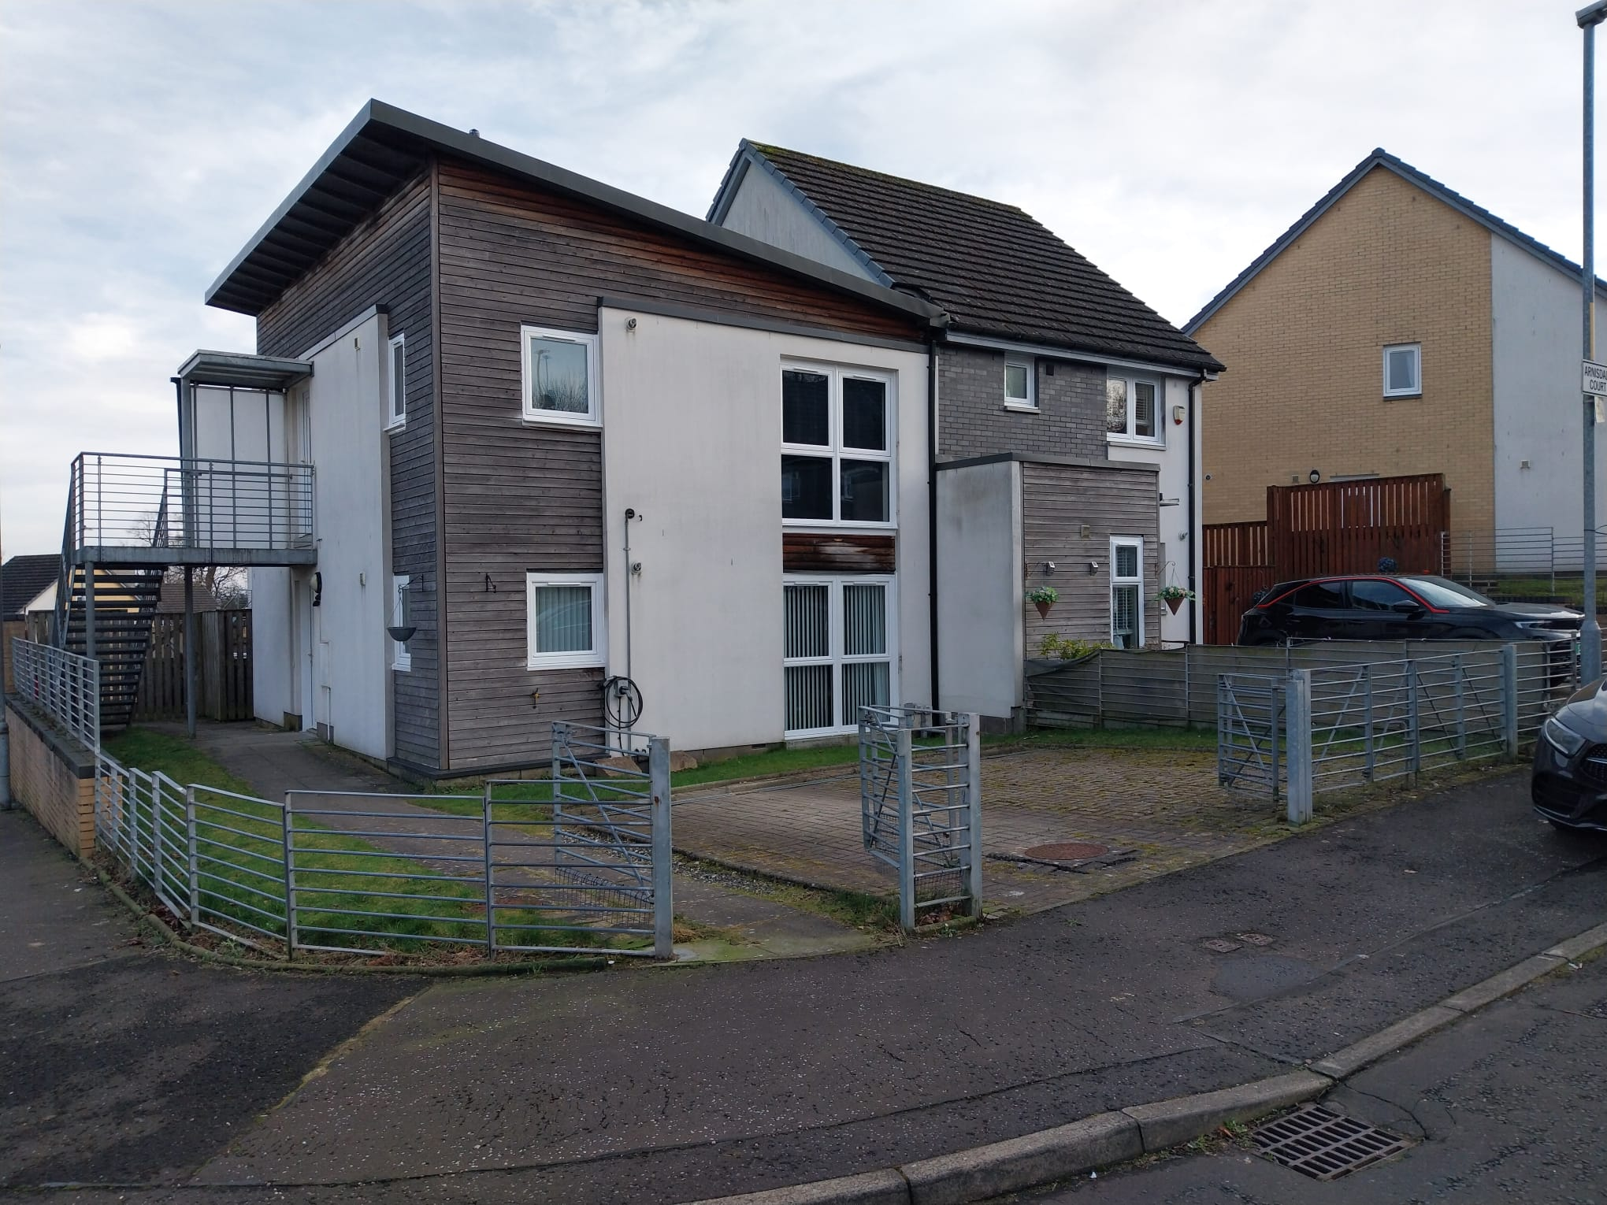


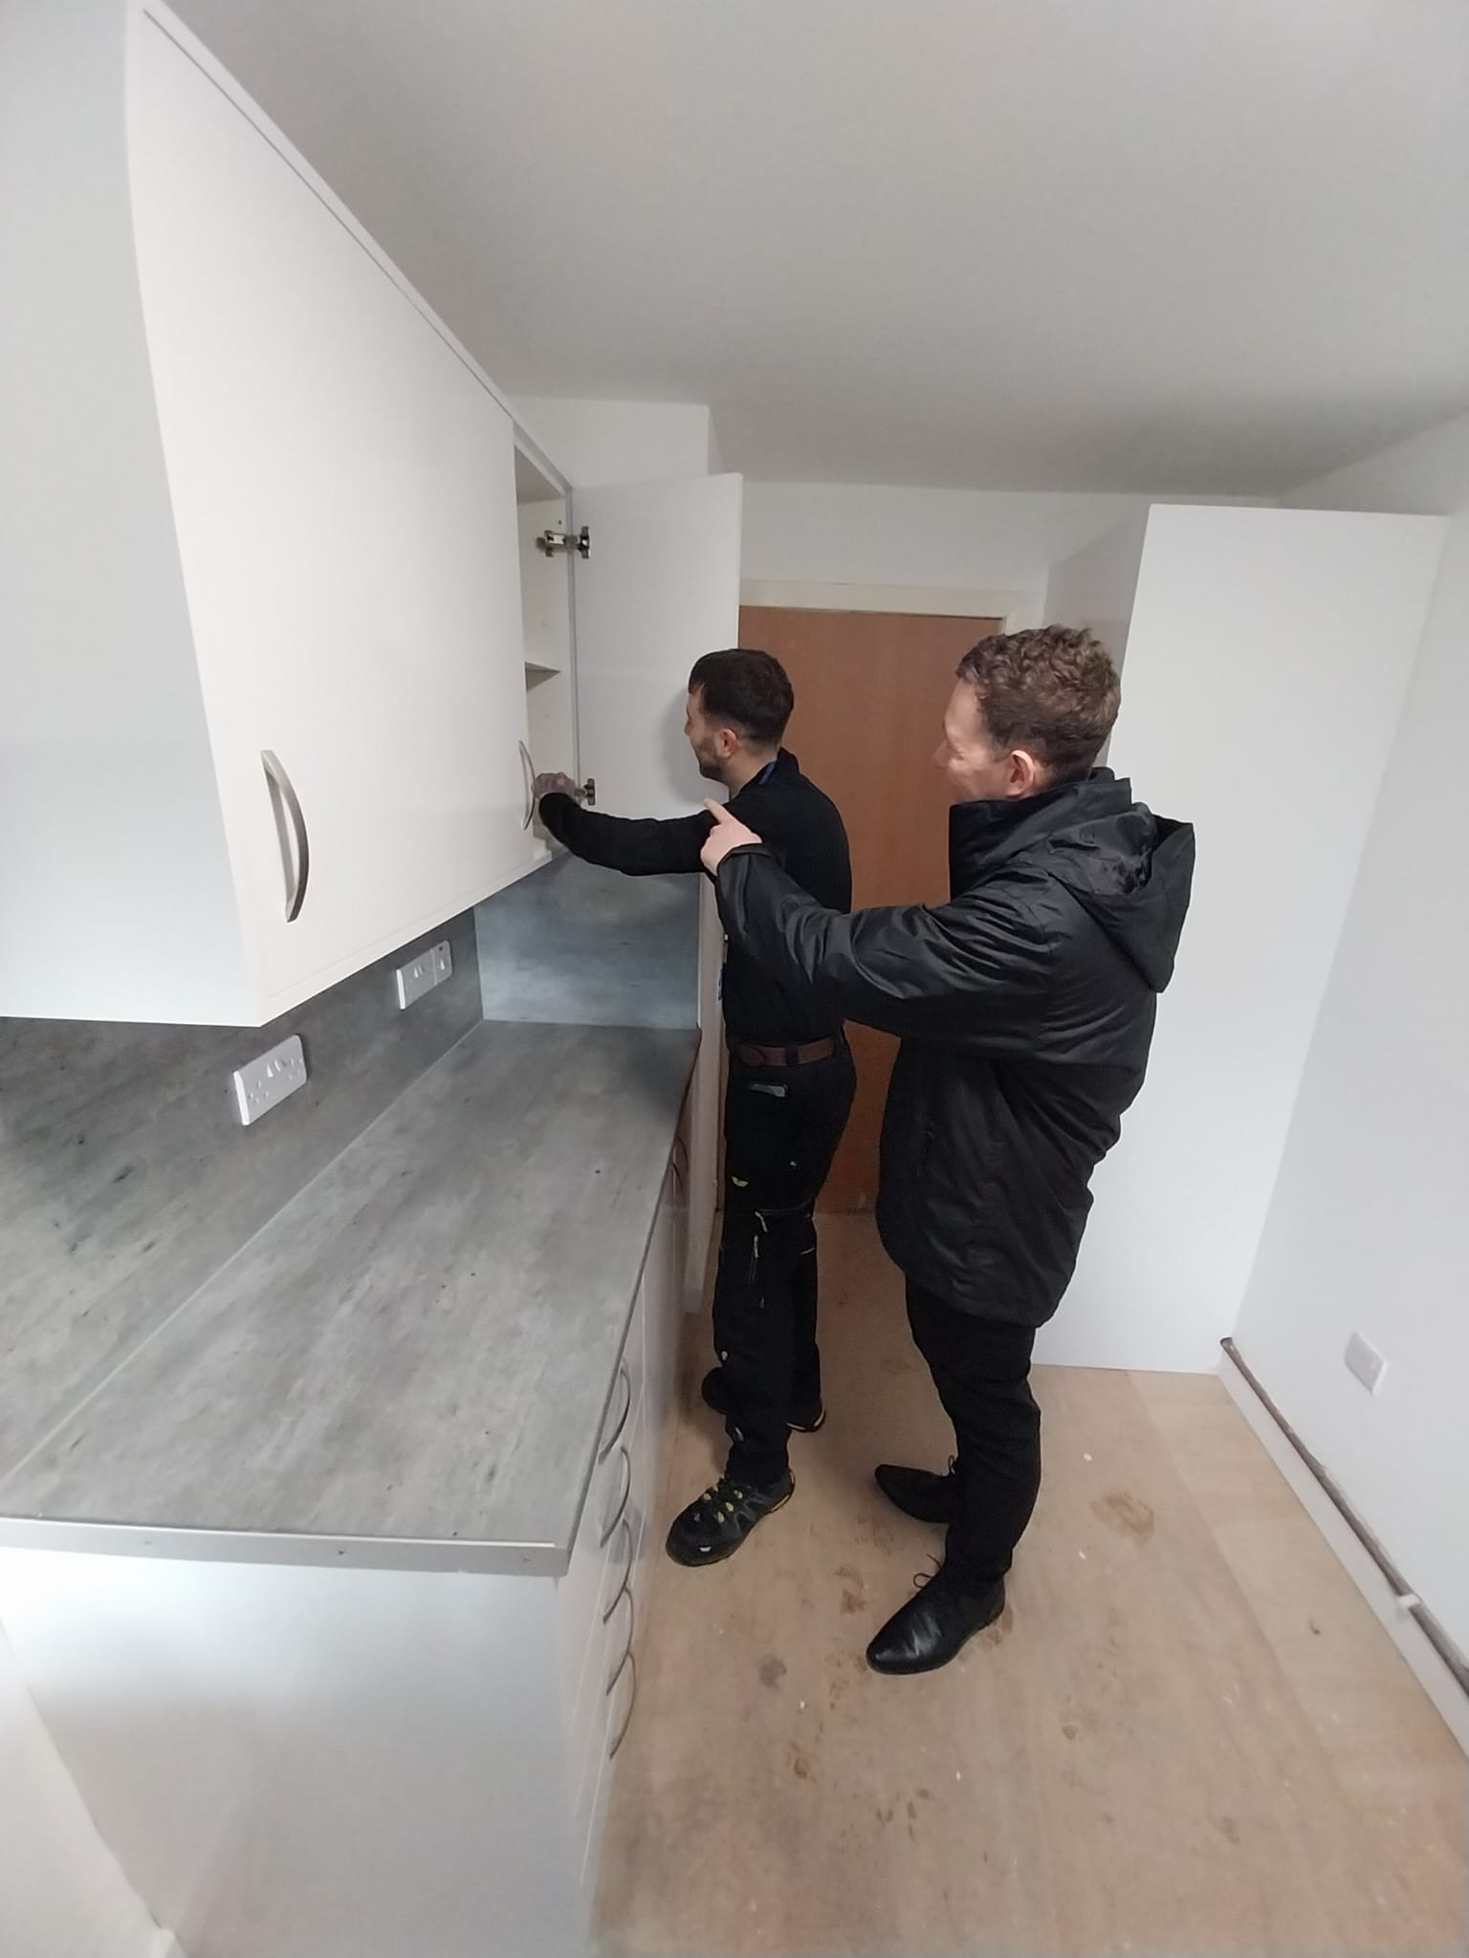



Contents

- Welcome
- About Easthall Park Housing Association
- Our Vision, Objectives & Values
- Summary of Terms & Conditions
- Job Description & Person Specification
- How to Apply

1. Welcome
Thank you for your interest in the Head of Maintenance’s role at Easthall Park. I hope the information in the pack and our website will encourage you to apply for the role.
Easthall Park has been on a journey of improvement, where our staff team have excelled to deliver
As the Head of Maintenance you will lead and inspire the maintenance team to build relationships with our tenants and other stakeholders to deliver a customer focussed service in the delivery of high quality, compliant and responsive maintenance service.
It is an exciting time to join Easthall Park and be part of our journey to further improve our maintenance service and lead our in-house trade team and suite of contractors to excel and exceed the expectations of our tenants in the maintenance and improvement of their homes. We have plans to develop our in-house trade team to attend to cyclical and planned major repair works to achieve our vision to make Easthall Park – ‘ A Great Place to Live’.
We are looking for leader who is passionate about customer service, is seeking a person with experience and a successful track record in delivering a high performing maintenance service and will lead and motivate the maintenance team to achieve successful outputs and outcomes for the business, our tenants and other stakeholders. The successful candidate should also be passionate about customer service, positive, energetic, dynamic and be committed to our organisational values.
If you relish the challenge and opportunities of this role and feel you have the skills, knowledge, experience and personal attributes to make a major contribution as a member of the senior management team and to lead the maintenance team to achieve continuous improvement, we would be delighted to hear from you.

Kenny Mollins
Director

2. About Easthall Park Housing Association

Easthall Park Housing Association (Easthalll Park) is a registered social landlord and was formed in 1992 to improve the housing conditions in the Easthall community in the peripheral area of Easterhouse in the north east of Glasgow.

Easthall Park evolved through major regeneration of new build housing and a stock transfer from Glasgow Housing Association. We now own 694 properties and provide a factoring service to 55 owner-occupiers in the Easthall and Kildermorie communities in Easterhouse.

Easthall Park is community based and focussed on improving the quality of lives and living conditions of our tenants and residents living in our communities. We feel we are successful in managing our communities and tenants’ homes and delivering a high quality and responsive service. This view was tested through the Tenant Satisfaction Survey in 2023 and the highlights from the survey were as listed:
- Overall satisfaction with service provided - 92%
- Satisfaction on being kept informed about services and decisions.- 97%
- Satisfaction with the management of the neighbourhood - 97%

The findings of the survey highlighted tenants’ view of our repairs and maintenance service, which align with our performance, these are as listed:
- Satisfaction with the repairs service - 79%
- Satisfaction with the quality of their home - 85%

There are 23 staff members in our team following a full review of our staff structure to ensure we have the resources to excel and achieve our new vision for the service in Easthall Park. Our staff mainly work in housing management, maintenance, and finance & corporate services to deliver the local housing service to our tenants and other customers. We have an in-house Trade / Estate Teams to attend to environmental maintenance, re-active repairs and void works. We aspire to further develop the Trade Team to attend to other re-active work, as well as cyclical and planned major repairs.

Easthall Park is in a good financial position, with healthy cash reserves, surplus years throughout our 30 year financial plan; good quality housing with strong SHQS compliance and energy efficiency ratings; and low turnover and high demand in the housing stock. We have recently completed the stock condition survey, which will inform our Investment Strategy and financial wellbeing and the development of our new Asset Management Strategy.

Easthall Park prides ourselves in our achievements in housing regeneration; being local and community based, delivering high quality and responsive services, and being more than a landlord working in partnership with Easthall Residents Association (ERA).


Easterhouse is a very deprived area and our communities in Easthall and Kildermorie are well within the worst 10% most deprived areas in Scotland based on the Scottish Indices of Multiple Deprivation. We continue to support and work in partnership with ERA to pursue grant funding opportunities aimed at improving our tenants and other residents’ quality of lives, particularly during the cost of living crisis.


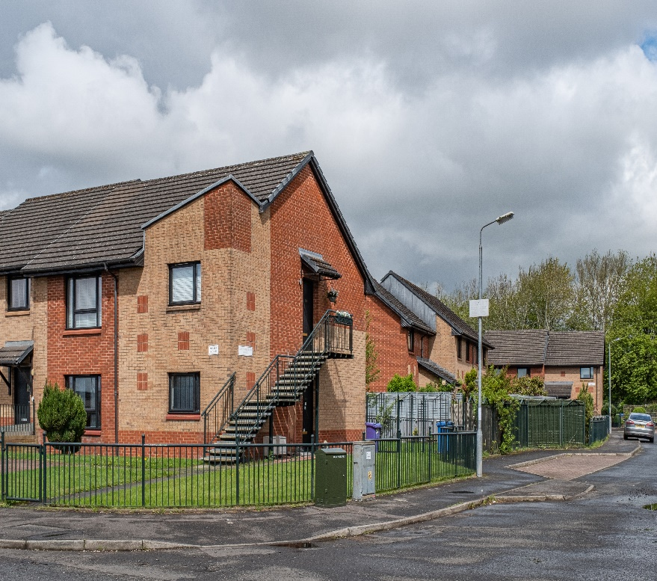
Easthall Park works with other housing associations in the Easterhouse, where we are members of the Easterhouse Housing and Regeneration Alliance (EHRA). EHRA members meet on a strategic and operational level to work collaboratively to represent, protect and promote the interests of its communities and people in Easterhouse, as well as improve in our work and services and achieve best value for money.

3. Vision, Mission, Strategic Objectives and Our Values

The Management Committee and staff developed the Association’s strategic direction for 2023-26 through the following:

Vision

Easthall Park - “A Great Place to Live”

Mission

“Providing high quality and affordable housing and responsive services to our tenants and residents”.

Strategic Objectives

We have established 5 Strategic Objectives that reflect our Vision, Values, Mission and overarching aims:
SO 1 - Delivering Excellent Housing Services
SO 2 - Providing Quality Homes in an Attractive Environment
SO 3 - Demonstrating Good Governance
SO 4 - Achieving Strong Financial Management & Best Value for Money
SO 5 - Being More than a Landlord to improve the lives of our tenants and
residents.
Values
Through our Values our aim is to T.H.R.I.V.E as a business:
- Teamwork - We will support each other to achieve in our work.
- Honesty - We will be trustworthy, transparent, and conscientious.
- Relationships - We will have positive relationships with our tenants,
colleagues and other stakeholders.
- Integrity - We will be respectful, responsible and caring.
- Visionary - We will be forward thinking.
- Excellence - We will deliver high quality and responsive services and
be committed to continuous improvement.

4. Summary of Terms & Conditions

Easthall Park is a full member of Employers in Voluntary Housing (EVH) and we adopt their terms and conditions and salary structure in our management of human resources.

A summary of the key terms for the role of Head of Maintenance are as listed:

- Place of Work - Glenburn Centre, 6 Glenburnie Place, Easterhouse,
G34 9AN

- Salary - EVH Grade 9 – Spinal Points SM4 – SM6
£61,206 - £64,739.

- Hours of Work - 35 hours per week, Monday to Friday
Flexible / hybrid working.

- Holiday Entitlement - 25 days per annum and 15 days public holidays
Flexible use of public holidays.

- Pension - A SHAPS Defined Contribution pension scheme is
Offered on the following terms (Employee contributions 5% and Employer contributions 10%).

- Probationary - There is a 6 month probationary period.

- Other Benefits

  - Life Cover - There is death in service cover of 3 times the annual salary.
  - Professional Membership Fees
  - Canada Life We Care – Health & Wellbeing Service
  - Counselling Service
  - Commitment to Learning and Development

5. Job Description & Person Specification

JOB DESCRIPTION

JOB TITLE: Head of Maintenance

GRADE: Employers in Voluntary Housing Grade 9 Spinal Points
SM4 – SM6

RESPONSIBLE TO: Director

ACCOUNTABLE TO: Management Committee through the Director

RESPONSIBLE FOR: Maintenance Team

DATE: November 2023

Main Objectives of Post
- To contribute to the development of the Business Plan and associated strategic and operational work plans to achieve organisational objectives.

- Lead, manage and empower the maintenance team to deliver a professional, high quality, efficient and responsive service.

- Manage and ensure continuous improvement in key areas of the maintenance service to achieve good outcomes for the Association and its stakeholders.

- To ensure the provision of excellent customer service in the delivery of the maintenance service

- To procure and manage all maintenance contracts.

- Develop and manage the in-house maintenance service ensuring it is fully productive, efficient and contributes to organisational objectives i.e., excellent customer service, best value, etc.

- Ensure compliance with the management of health & safety associated with the repairs service and management of the in-house trade team.

- Contribute to the project management of new build development and renovation projects.

- Lead in the development of Investment Plans through cyclical and planned major repair works in our tenants’ homes and the common property.

- To service the needs of the Management Committee in relation to the work of the Maintenance service

- Attend to other duties in keeping with the role of Head of Maintenance.

Principal Duties

- To contribute to the development of the Business Plan and associated strategic and operational work plans to achieve organisational objectives.

- Contribute towards the development and review of key strategic documents and plans e.g., Business Plan, Risk Register, Financial Plans, etc.
- Contribute towards the Scottish Housing Regulator’s regulatory requirements through the Regulatory Framework and specifically the Annual Assurance Statement and the Scottish Social Housing Charter.
- Identify strategic solutions to effectively manage risk and improve performance and our service through implementation of the Performance Management Frameworks and internal control systems.
- Assist the Director to develop an Asset Management Strategy to inform the viability and long term sustainability of the Association’s housing stock.
- Provide property data to assist the Finance & Corporate Services Manager to procure funding for the Association’s development and regeneration activities.
- Assist the Finance & Corporate Services Manager in procuring independent periodic stock valuations to ensure compliance with loan covenants and accounting arrangements.
- Manage, monitor and control Maintenance budgets.

- Lead, manage and empower the Maintenance Team to deliver a professional, high quality, efficient and responsive service.

- Provide leadership and direction to the Maintenance Team to ensure they deliver a high quality, effective and efficient service to achieve organisational objectives and good outcomes for key stakeholders e.g. tenants, owner-occupiers, customers, etc.
- Develop and review policies and procedures to ensure the delivery of the maintenance service meets: legislative and regulatory requirements; organisational objectives, and good practice guidance
- Ensure regular and effective communication with the Maintenance Team on an individual and collective basis.
- Lead on HR and personal development of the Maintenance Team e.g., annual performance reviews, staff training, personal development and welfare, attendance management and the management of leave.
- Develop and maintain performance monitoring systems in relation to the achievement of key tasks and service and financial targets in the delivery of the maintenance service.
- Ensure the Director and Management Committee are advised on any significant performance or service issues that may impact on the Association’s financial position, regulatory status or seriously affect the service to our tenants or other customers.

- Manage and ensure continuous improvement in key areas of the housing service to achieve good outcomes for the Association and its stakeholders.

- Deliver a high quality and responsive re-active repairs service through the in-house trades staff and external contractors to achieve targets for performance and tenant satisfaction and best value for money.
- Deliver a programme of cyclical and planned maintenance improvements annually to maintain tenants’ homes and the common property.
- Ensure full compliance with landlord safety works i.e. annual gas servicing, 5 year electrical inspection, annual water hygiene checks and servicing, fire safety and asbestos management.
- Ensure maintenance works to void properties is undertaken timeously to positively contribute towards void lost rent targets.
- Manage medical adaptations improvements to tenants’ homes in conjunction with key stakeholders. Administer the HARP system to ensure claims and applications for maintenance works are processed timeously.

- To ensure the provision of excellent customer service in the delivery of the maintenance service
- Contribute to the resident satisfaction survey.
- Analyse trends in complaints and initiate improvements in the maintenance service.
- Maintain regular customer surveys in key areas of maintenance service and develop improvement plans.
- Ensure adherence of the Scottish Public Sector complaints model and provide monitoring reports to the Senior Management Team and Committee

- To procure and manage all maintenance contracts

- Prepare and issue tender documents including specifications for works for maintenance contracts and services on a cyclical basis.
- Undertake the tender process in accordance with the Maintenance and Procurement policies and procedures.
- Lead in the Association’s contract with Scotland Excel and support and assist staff to ensure best value through access to their framework agreements for all our services, supplies and works.
- Maintain and review annually all contractors’ records and documentation in relation to financial position, public indemnity, insurances, and appropriate training accreditations of employees.
- Ensure regular meetings are convened with contractors to discuss performance and other contract matters in the delivery of the maintenance and service contracts.
- Ensure contractor’s performance is monitored and controlled against targets and quality standards. Take early action to attend to any non compliance in the delivery of a contract to affect service improvement to tenants and other customers.

- Develop and manage the in-house maintenance service ensuring it is fully productive, efficient and contributes to organisational objectives i.e. excellent customer service, best value, etc.

- Develop and review systems to ensure the in-house trade team is viable and sustainable and provides a high quality and responsive service to our tenants and other customers in the maintenance of the Association’s properties.
- Ensure in-house maintenance staff operates in accordance with legislative provisions and good practice in undertaking repairs and improvement works.
- Ensure effective administration of all work orders for both the internal Trade Team and external contractors are managed in accordance with the relevant procedures.
- Ensure effective arrangements for the procurement and replenishment of equipment and materials to ensure repairs and improvements are undertaken within contract timescales.
- Develop a network of suppliers for maintenance materials and maintain stores for the in-house Trade Team to obtain the necessary equipment and materials to undertake repairs and improvement works. Undertake a periodic review of stock and reconcile against purchases and completed repairs and improvement works.
- Monitor performance of the in-house maintenance service and contractors as required. Instruct key personnel to take appropriate action to effect improvement in service when required.
- In conjunction with the Finance & Corporate Services Manager annually undertake a best value review of the in-house maintenance service and report to the Management Committee.
- In conjunction with the Housing Manager recruit apprentices, trainees and volunteers to undertake training and work experience placements through our Trade & Estates Teams’ operations.
- Develop effective administration systems for all training and work experience placements e.g., recruitment, induction, progress meetings, training plans, funding arrangements and exit interviews.

- Ensure compliance with the management of health & safety associated with the repairs service and management of the in-house trade team.

- Ensure compliance with Health & Safety and risk assessments associated with repair and improvement works and the management of welfare facilities for Trade & Estates Team.
- Ensure all contractors used by the Association meet Health and Safety requirements.
- Develop and review a suite of risk assessments, method statements and COSHH assessments for the in-house Trade Team’s work and activities.
- Ensure external contractors provide risk assessments and method statements for their work and activities including COSSH assessments prior to the issue of work orders.
- Achieve full compliance with our legal obligations associated with the Management of Asbestos.
- Achieve full compliance with fire safety and Electrical regulations and guidelines for the Association’s housing stock and premises.
- Ensure welfare facilities are provided and well maintained for the Trade and Estates Team.
- Maintain health & safety information e.g., audit reports and actions, plans, risk assessments, method statements.
- Lead in the development and work of the Health and Safety Working Group in conjunction with the Corporate Services Officer (H&S Administrator).

- Contribute to the project management of new build development and renovation projects.

- Contribute to the development of proposals for potential development and regeneration projects aimed at improving our housing stock and communities in Easthall Park in conjunction with the Director and Development Consultants.
- Assist in the procurement of development and regeneration projects in accordance with the Procurement Policy.
- Manage development and regeneration projects ensuring progress and the financial position is in keeping with contract timescales.
- Attend regular meetings with the Association’s Design Team and / or contractors to attend to any contract issues.
- Promote and provide regular reports and updates on the progress of development or regeneration projects to key stakeholders e.g. Management Committee, Tenants, local residents, Glasgow City Council, funders, lenders, etc.
- Manage the defects period in accordance with the jointly prepared procedure with the developer / regeneration contractor.

- Lead in the development of Investment Plans through cyclical and planned major repair works in our tenants’ homes and the common property.

- Develop and publish investment plans for the short, medium and long term, which meets the Association’s business plan and reflects stock condition information and needs and aspirations of our tenants and other customers.
- Periodically update data information on the condition of the Association’s properties to inform our investment plans, through our records and cyclical independent stock condition surveys.
- Publish annually the 5 year investment plans for cyclical and planned maintenance works to tenants and other customers e.g. owner-occupiers
- Maintain the Planned Maintenance module on the SDM Housing Software system to ensure an effective record of planned and cyclical improvement works in voids, tenant’s homes and the general fabric of our properties.

- To service the needs of the Management Committee in relation to the work of the Maintenance service

- To attend and service the Management Committee or designated sub-Committee meetings as required.
- Ensure that the Management Committee are advised of any change in legislation or other guidance which could affect the manner in which the Association delivers its maintenance service.
- Ensure the provision of good quality reports for information and decision-making in maintenance service and activities.
- Report to the Management Committee on all aspects of the Maintenance Team’s performance.

- Attend to other duties in keeping with the role of Head of Maintenance

- Positively contribute as a member of the Senior Management Team Staff Team to achieve organisational objectives and goals.
- Ensure effective collaboration and co-operation between sections.
- Chair internal working groups as and when required
- Contribute to wider role and regeneration strategies and work aimed at improving services, activities and tenants’ quality of life.
- Participate in promotional, marketing and community events relating to the Association’s work.
- Contribute to the development or review of the SDM Housing Software System to maximise efficiencies and service delivery.
- Be committed to their own professional and personal development to meet the needs of the role and the Association.
- Demonstrate commitment to the Association’s Equal Opportunity & Diversity Policy and codes of practice.
- Attend meetings at evenings or weekends, as required in relation to your role and the Association’s work
- Support the development and work of the Association strategic partnership with Easthall Residents Association
- Carry out any other tasks commensurate with your role as directed by the Director or Management Committee

PERSON SPECIFICATION
Head of Maintenance

 | Essential | Desirable
Education & Qualifications
Professional, Technical or other Construction related qualification
HND or Degree Qualification
A professional member of Chartered Institute of Housing or Professional Body.
Driving Licence
Experience
Minimum of 5 years’ experience in maintenance and development services
Experience working with Microsoft applications
Minimum of 3 years managerial or supervisory experience
Experienced in managing and monitoring the performance, financial budgets and tenant satisfaction for the repairs service.
Experience of policy and procedural development in the delivery of the maintenance and development functions
Preparing investment plans based on stock conditional data and other factors
Preparing tender documents for maintenance contracts and administering the tender process in accordance with legislative and policy requirements.
Working for a Voluntary Committee
Proven track record in leading a maintenance team and developing people to deliver a high quality and response service
Established successful partnership working with other agencies / organisations to meet organisational goals
Experience of developing new systems and working practices to improve efficiency in a maintenance setting
Experience of managing a Direct Labour service and maintenance contractors
Experience in the housing association sector
Experience with SDM housing software system (asset and planned asset modules)
Skills, Abilities & Personal Attributes
A dynamic individual committed to continuous improvement, customer service excellence and innovation
Ability to demonstrate strategic thinking and planning
Excellent report writing, presentation and communication skills
Good interpersonal and team working skills
Ability to negotiate and influence others to meet the objectives of the Association
Highly motivated to excel in role
Highly proficient in IT
Customer focused
Ability to plan and prioritise work to meet personal targets and organisational goals
Ability to handle a heavy and diverse workload and the pressures of conflicting priorities and demonstrate good time management to meet challenging deadlines
Ability to accept the responsibilities of the post
Flexible in approach to work
Ability to empower, motivate and inspire staff
Knowledge
Legislative and good practice requirements in the requirements of maintenance and development services within the housing association sector
Excellent knowledge of current building and landlord compliance to ensure tenant safety i.e. Gas, Electrical, Fire, Asbestos and Water Hygiene regulations.
Scottish Housing Regulator’s Regulatory Framework and Scottish Housing Charter requirements
Business and Investment Plans in the work of a housing association / Association
Microsoft Applications, in particular, word, excel and powerpoint.
Good knowledge of wider role and regeneration opportunities
Other Requirements
Awareness of equality issues and commitment to meet the Association Policy and codes of practice
Committed, flexible and adaptable approach to work requirements
Uphold the Association’s values and objectives
Commitment to continuous improvement
Basic Disclosure

- How to Apply

To apply for this post, please submit your CV and a support statement detailing how you will meet the requirements and essential criterial for this post to our recruitment mailbox at recuitment@easthallpark.org.uk.

You should also complete and submit the following documents which are listed in appendices to this recruitment pack and are available on recruitment page of Easthall Park’s website (www.easthallpark.org.uk/vacancies)

- Compliance with the Person Specification
- Recruitment Declaration Form.
- Equal Opportunities Monitoring Pro-forma.

You following documents are available on our website.

- GDPR Fair Processing Agreement – Job Applicants.
- Business Plan 2023-26.
- Corporate Risk Register 2024-25.

The recruitment pack and associated forms can be accessed on the Association’s website –
www.easthallpark.org.uk/about/vacancies

You can contact the Association’s Director, Kenny Mollins to discuss the role on 0141 781 2277.

The closing date for applications is Monday 30 March 2026 at 1.00p.m.

The Recruitment Panel will shortlist applicants and they will be invited to an interview to be scheduled in April 2026. The Recruitment Panel will consider the need for a second interview, if required.

Appendix 1 Compliance with the Person Specification

We have selected key areas of the person specification and we require you to provide details of your experience, knowledge and achievements in these key areas of the role. There is a maximum of 500 words for your response to each area of the person specification.

Criteria 1 Proven track record in leading a maintenance team and
developing people to deliver a high quality and response service

Criteria 2 Experienced in managing and monitoring the performance,
financial budgets and tenant satisfaction for the repairs service.

Criteria 3 Preparing investment plans based on stock condition data and
other factors.

Criteria 4 Preparing tender documents for maintenance contracts and
Administering the tender process in accordance with legislative
and policy requirements.

Criteria 5 Experience of managing a Direct Labour service and maintenance
contractors

Criteria 6 Experience of policy and procedural development in the
delivery of the maintenance service

Appendix 2 Recruitment Declaration Form.


Recruitment Declaration Form
Position Applied For: | Head of Maintenance

Contact Details
Title |  | First Name |  | Surname
Address:

Mobile Number |  | Discretion | Yes / No
Home Number |  | Discretion | Yes / No
Work Number |  | Discretion
E-mail Address

Curent Role
Job Title |  | Salary | £
Notice Period

Rehabilitation of Offenders Act 1974
Easthall Park Housing Association is committed to recruitment of people from all areas of the community including offenders and ex-offenders.

The Rehabilitation of offenders Act 1974 requires us to ask if you have any ’unspent convictions. This information you provide will be treated in the strictest confidence and only be taken into account where, in our opinion, the offence is relevant to the post for which you are applying. If you inadvertently disclose a ‘spent’ conviction it will be ignored.

Under the Exception Order 1995 certain types of employment and professionals are exempt from the Rehabilitation of Offenders Act 1974 and in cases for example where the employment sought involves working with children or vulnerable adults, details of all criminal convictions- both spent and unspent must be disclosed.

If you are unsure whether your conviction(s) should be disclosed please check http://www.nacro.org.uk/what-we-do/resettlement-advice-service/advice/disclosing-criminal-records/ rehabilitaton-ofoffenders-act1974

Failure to declare a conviction may result in your exclusion from the recruitment process or termination of any employment if the offence is not declared, but later comes to light.

Do you have any unspent criminal convictions or spent convictions covered by the Exception Order 1995 | Yes / No

Asyum & Immigration Act 1996
We have a legal responsibility to verify your immigration status / eligibility to work in the UK under the terms of the Asylum & Immigration Act 1996. Proof will need to be provided

I can confirm I am entitled to work in the UK. |  | Yes / No
Proof of Eligibility
e.g. passport, Driving Licence, Birth Certificate

References
Please provide full contact details of two referees you have worked for or with. One of the referees should be your current or most recent employer. References will not be taken until you have been offered the job.

 | Referee 1  (Current / most recent employer) | Referree 2
Full name:

Position:

Organisation:

Relationship to You

Address:

Postcode
Work Number

Mobile Number

E-mail Address

Declaration
Are you related or close friends with any members of the Management Committee or staff of Easthall Park Housing Association? | Yes / No
Are you related or close friends with any former  members of the Management Committee or staff or Easthall Park Housing Association within the last year? | Yes / No
Are there any other potential conflict of interest you may be aware of related to this application for employment with Easthall Park Housing Association? | Yes / No
If you have answered Yes to the above questions in the Declaration section please provide details:

- I herby confirm the information given in my CV, Supporting Statement and this recruitment declaration form is trus and correct.

- I understand any offer of employment is conditional upon the accuracy of this information and any false or misleading information, as well as withholding relevent information, may lead to my application being disqualified, the withdrawl of a job offer; or if I have been appointed, to my dismissal.

Name – Print _________________________________

Name – Signed __________________________________

Date: __________________________________

Appendix 3 Equal Opportunities Monitoring Pro-forma

EQUAL OPPORTUNITIES MONITORING FORM
Completion of this form is voluntary and the contents will remain anonymous.

Easthall Park Housing Association is committed to equal opportunities in employment, regardless of: age, disability, gender reassignment, marriage & civil partnership, pregnancy & maternity, race (including colour, nationality ethnic or national origins and citizenship), religion/belief, sex and sexual orientation.

If you wish to assist us in achieving a diverse workforce, and advertising our vacancies appropriately, please complete the following questionnaire.

If you do not wish to complete the form, this will have no bearing on any selection decisions.

All information will be treated in the strictest confidence, processed anonymously and separately from any application form you submit. The information will not be provided to or shared with the shortlisting or interview panel. Our Data Protection Privacy Policy can be found on our website.

Position Applied For: ___________________________________________

Gender: Male Female
Prefer not to say
Prefer to self describe, please provide details __________________

Disability: Do you consider yourself to have a disability/special needs? Yes No

Ethnic Origin: Please choose ONE section from A to E, then tick the appropriate box to indicate your cultural background.

A White B Mixed C Asian or Asian D Black or Black
Scottish/British Scottish/British
English Any mixed Indian Caribbean
Scottish background Pakistani African
Welsh Bangladeshi Other black
Irish Chinese
Polish Other Asian
Gypsy Traveller
Other white

E Other ethnic group Prefer not to say
Arab, Arab Scottish/British

Any other ethnic group (please state) _________________

Religion: I would describe my religious background/belief as: ________________

None I prefer not to say

Sexual Orientation:

Bi-sexual Gay/Lesbian Heterosexual/Straight

Prefer not to say Prefer to self describe, please provide details __________________

Age: Please indicate your age group.

16 - 24 25 - 34 35 - 44 45 - 54 55 - 64 65 & over

Where did you see this post advertised?

Association’s Website S1jobs.com EVH Website Word of mouth

Other If other please state: _______________________________

